**Exercise Generics**

1. Create a Generic class Pair that represents a Pair of General Type.
2. Modify the above class so that the Pair may be generated for two different generic types.
3. Write a generic class, MyMathClass , with a type parameter T where T is a numeric object type (e.g., Integer, Double, or any class that extends java.lang.Number ). Add a method named standardDeviation that takes an ArrayList of type T and returns as a double the standard deviation of the values in the ArrayList . Use the doubleValue () method in the Number class to retrieve the value of each number as a double. Test your method with suitable data. Your program should generate a compile-time error if your standard deviation method is invoked on an ArrayList that is defined for nonnumeric elements (e.g., Strings ).
4. Create a generic class with a type parameter that simulates drawing an item at random out of a box. This class could be used for simulating a random drawing. For example, the box might contain Strings representing names written on a slip of paper, or the box might contain Integers representing a random drawing for a lottery based on numeric lottery picks.

Create an add method that allows the user of the class to add an object of the specified type along with an isEmpty method that determines whether or not the box is empty. Finally, your class should have a drawItem method that randomly selects an object from the box and returns it.

If the user attempts to drawn an item out of an empty box, return null . Write a main method that tests your class.

Note: Create data of the class yourself as per the requirements of the questions.

1. Implement the code below:

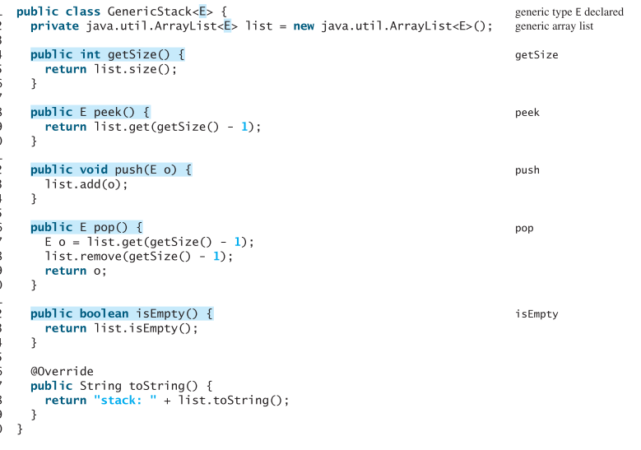

Runner:

